
SOP Title: | eCommerce Returns Processing
Document Storage Location: | STACS/Management/SOPs – Logistics and Warehousing | Document #: | SEASOP434v100
SOP Originator: | Avika Raja | Last Edited by: | Erwin Dela Pena
Effective Date: | 08/06/2021 | Last Edited Date: | 12/18/2023
Other: | Visibility and Workbench access required.

- Purpose
  - To outline the customer Return Merchandise Authorization (RMA) process, which must be processed within 48 hours once arrived (24 hours for receiving, 24 hours for Put Away).
- Scope
  - Coppell eCommerce (eComm): All RMAs sold through Samsung.com.
- Responsibilities
  - The 3PL eComm team (3PL) shall be responsible for the systemic 3PL Warehouse Management System (WMS) processes and physical activities within eComm operations.
  - The SEA Logistics Planning & Services (LPS) eComm team shall provide oversight for 3PL operations and validate performance.
  - The 3PL eComm and SEA LPS eComm teams shall collaborate on troubleshooting procedures for Exceptions processing when required.
- Instructions
  - Customer Returns Product
    - Customer logs on to Samsung.com and requests a shipping label for the device they are returning.
      - The customer should return the delivered product within 15 days of receipt.
    - Customer prints out the shipping label with the RMA and RDO (Return Delivery Order) codes and applies it to the return package.
    - Customer takes the package to a FedEx location for shipment.
  - FedEx shall deliver package within 7 days of customer drop off.
    - If the package is not delivered within 14 days of drop off, a claim will be filed with FedEx.
      - See Lost-In-Transit Inbound Claims SOP
  - Arrival
    - The product arrives at the Coppell Warehouse door assigned for FedEx delivery.
    - The 3PL Returns Team associate goes to assigned dock door and
      - Performs a dock scan of the tracking number
      - Separates the shipment based on type of return material:
        - Returns
        - Refusals (See SEASOP433v100)
        - Non-eComm (See SEASOP436v100)
    - The associate confirms dock scan information with FedEx.
      - If dock scan information is incorrect, reconcile number of missing boxes with FedEx.
      - If dock scan information is correct, proceed to next step.
    - The associate performs an arrival scan for the Returns material in 3PL WMS.
    - The associate brings the Returns and Refusals material to an available space in the eComm Returns Area.
    - The associate moves the material to an available space in 3PL Workstation Area.
  - 3PL’s Processing in 3PL’s WMS
    - Return shall be received within 24 hours of POD (proof of delivery).
      - If 3PL does not receive return within 24 hours, SLA (Service Level Agreement) is not met.
    - Product arrives at workstation for processing by 3PL eComm Team associate.
      - The returns associate will perform an initial video and photo capture of the return. The video and photo capture will take place as the associate opens the box.
Scan RMA code or manually enter RMA in 3PL WMS.
      - The outside condition of the box and the contents of the box will be recorded and filed for any future inquiries.
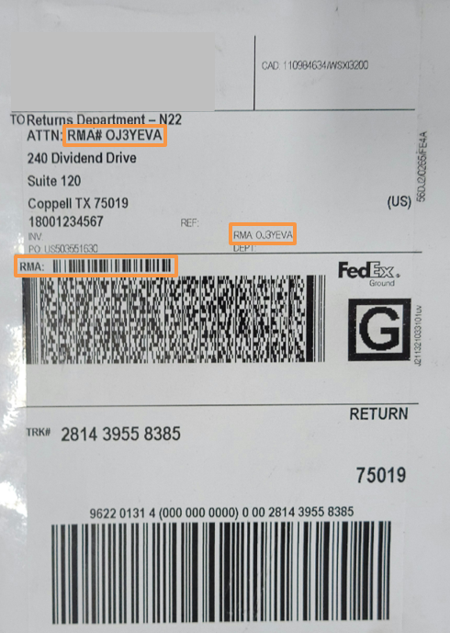
      - The associate will then scan or manually enter the RMA label to begin processing in Synapse.

      - Confirm product SKU and quantity match in 3PL WMS.
        - If SKU and quantity match, proceed to Assessment step. (4.D.3)
        - If SKU does not match, check Workbench for customer order information.
          - Move package to exceptions cart.
          - Follow Exception procedure.
        - If quantity does not match, check Workbench for customer order information.
          - If all items are missing
            - Move package to exceptions cart.
            - Follow Unsent procedure.
          - If some items are missing
            - Process and close out the items that are inside of the package.
            - Move package to exceptions cart.
          - Follow Unsent procedure for missing items.
    - Associate assesses product box.
      - Product Information Validation
        - Products scanned for serial number (S/N) include
          - Accessories (watch bands, phone cases)
          - Chargers (including wireless)
          - Galaxy Buds
        - Products scanned for IMEI include
          - Watches
          - Phones
      - If product was not shipped back inside of original product box
        - Check S/N or IMEI on product itself and scan to confirm match in 3PL WMS.
          - If product S/N or IMEI match
            - Repack product in new product box.
            - Proceed to Put Away Preparation step. (4.D.4)
          - If product S/N or IMEI do not match
            - Repack product in new product box.
            - Move product to exceptions cart.
            - Follow Exception procedure.
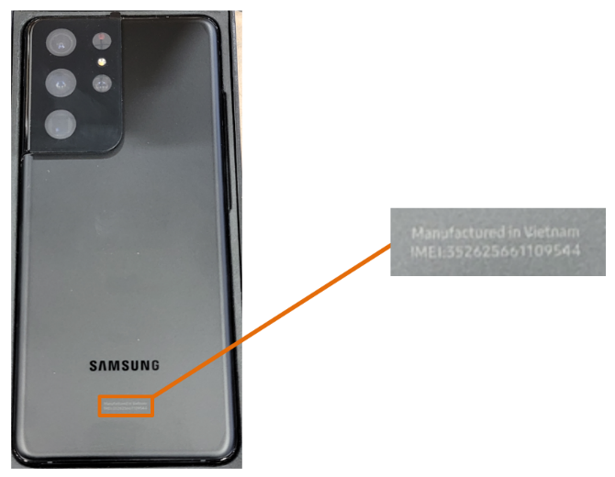
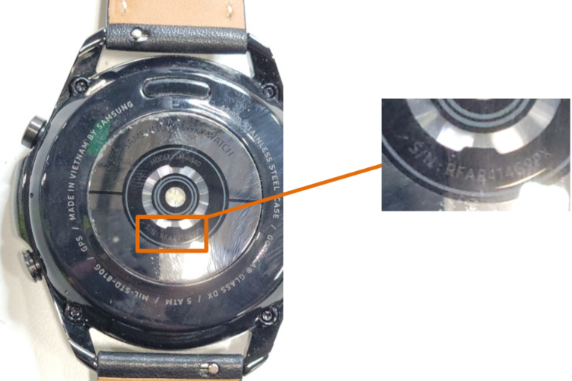
Enter S/N found on product in 3PL WMS.
Enter IMEI found on product in 3PL WMS.

      - If original seals on product box are not broken
        - Scan RMA on product box to confirm match in 3PL WMS.
          - If RMA does not match, follow RMA Mismatch procedure.
          - If RMA matches, proceed to next step.
        - Scan S/N or IMEI to confirm match in 3PL WMS.
          - If product S/N or IMEI match, proceed to Put Away preparation step. (4.D.4)
          - If product S/N or IMEI do not match
            - Move product to exceptions cart.
            - Follow Exception procedure.
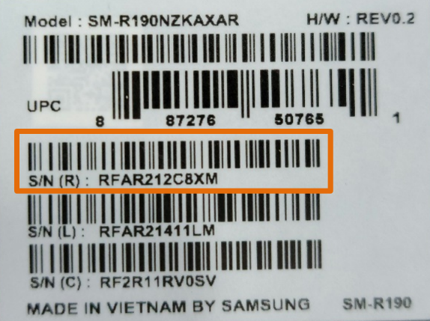
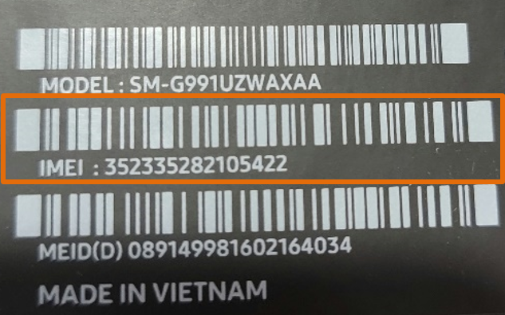
Scan S/N on product box in 3PL WMS.
Scan IMEI on product box in 3PL WMS.

      - If original seals on product box are broken
        - Scan RMA on product box to confirm match in 3PL WMS.
          - If RMA does not match, follow the Exceptions processing procedure.
          - If RMA matches, proceed to next step.
        - Check contents for missing items.
          - If RMA scan shows all items are accounted for
            - Check S/N or IMEI on product itself to confirm match in 3PL WMS.
              - If product S/N or IMEI match
                - Reseal product box.
                - Proceed to Put Away preparation step. (4.D.4)
              - If product S/N or IMEI do not match
                - Reseal product box.
                - Put product on exceptions cart.
                - Follow Exception procedure.
          - If RMA scan shows items not accounted for and
            - All items are missing
              - Log into Exceptions report and process as EBX.
            - Some items are missing
              - Process items that are accounted for and proceed to Put Away Preparation.
              - Follow Unsent procedure for missing items.
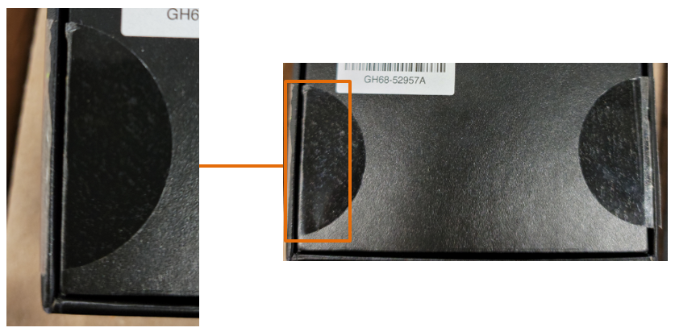
Broken seals on product box.

    - Put Away Preparation (performed by 3PL Associate).
      - If original seals on product box are not broken, product belongs in A-stock.
        - Scan SKU and IMEI or S/N as applicable.
        - Apply LIP (license plate) to new package box and scan.
        - Scan Acceptable (ACC) location code and Available (AV) reason code on workstation desk.
          - Indicates product is available for picking in interim virtual bin in A-stock.
        - Apply ‘Partial’ sticker to package box.
          - Cues picker to pick Partial box before vendor-sealed full box.
        - Write location listed in 3PL WMS on Partial sticker.
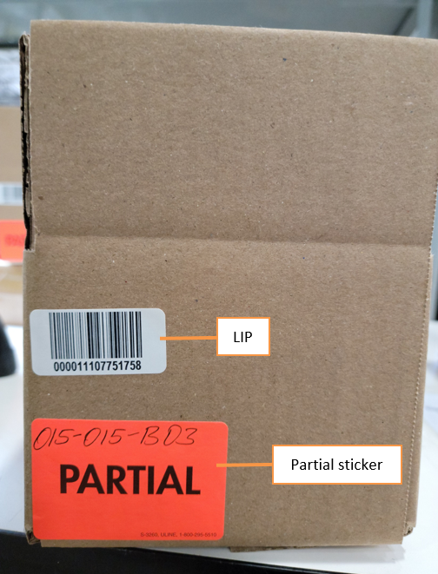
License plate (LIP) and Partial sticker are added to new package box for A-stock Put Away.
      - If original seals on product box were broken or product box was missing, product belongs in C-stock.
        - Scan SKU and IMEI or S/N as applicable.
        - Apply LIP to product box and scan.
        - Scan Damaged (DAM) location code and Return (RT) reason code on workstation desk.
          - Indicates product is available in interim virtual bin in C-stock.
Location and reason codes for A-stock and C-stock Put Away are located on 3PL associate’s workstation. desk.
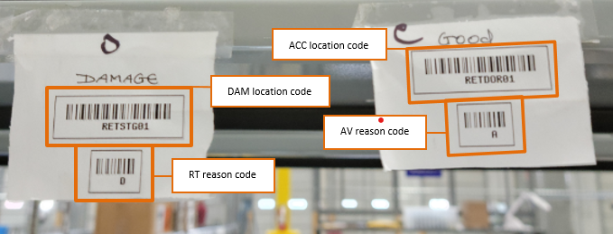
    - Confirm transactions in 3PL WMS.
    - As an additional check, associate verifies return information listed in 3PL WMS to ensure SKU and quantity match description.
      - If information does not match, process as Exception.
    - Complete the Return in 3PL WMS.
      - If product was DAM/RT, proceed to Put Away step (4.E).
      - If product was ACC/AV
        - Scan LIP again.
        - Change inventory status to “available” for picking.
        - Give ‘Reason for Change’ as “Put Away”.
      - Return is closed out in 3PL WMS.
      - Proceed to next step.
  - Put Away (done by 3PL associate on warehouse floor at EOD)
    - Associate enters Put Away functions in 3PL system.
    - Associate scans LIP.
      - If LIP is for DAM product, LIP is on product box.
      - If LIP is for ACC product, LIP is on package box.
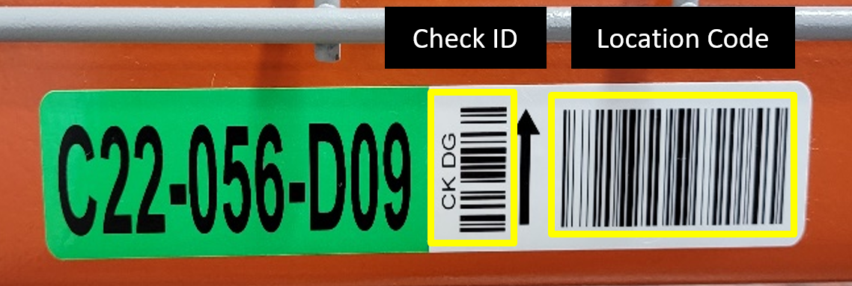
    - If product is ACC/AV, go to A-stock pick front on warehouse floor.
    - If product is DAM/RT, go to C-stock bin location on warehouse floor.
Scan Check ID and location code on warehouse shelf.
    - Scan location code on stock shelf to confirm match in 3PL WMS.
      - If location in 3PL system matches LIP, scan Check ID on shelf.
      - If 3PL system location does not match LIP, change location in 3PL system by scanning location code and Check ID on shelf.
    - Associate places product in assigned shelf location.
      - If product is DAM/RT, place in white bin.
      - If product is ACC/AV, consolidate in existing boxes.
      - If bin or box is full, use 3PL system to find open bin and enter reason code ‘NB’ (Next Bin).
        - Change location in 3PL system by scanning location code and Check ID on shelf.
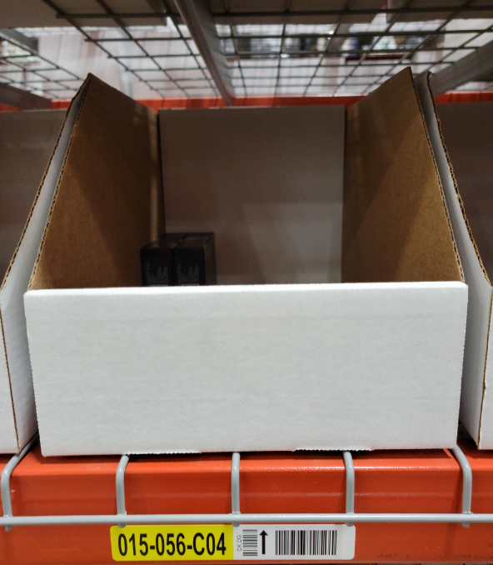
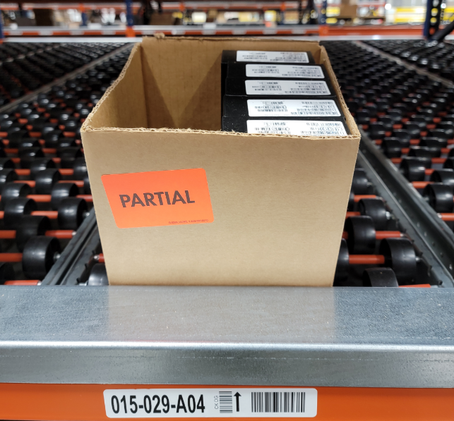
B-stock product is consolidated in white bins on warehouse shelf location.
A-stock product is consolidated in Partial boxes on warehouse shelf location.

